How to configure SCIM for CloudGate

Contents:
- Supported Features
- Requirements
- Configuration Steps

Supported Features:
- Create Users
- Update User Attributes
- Deactivate Users
- Push Groups

Requirements:
To configure SCIM for CloudGate, you need to have admin access to your client’s CloudGate web portal. You may also contact CloudGate support for any assistance with the configurations.

Configuration Steps

Step 1: Provisioning

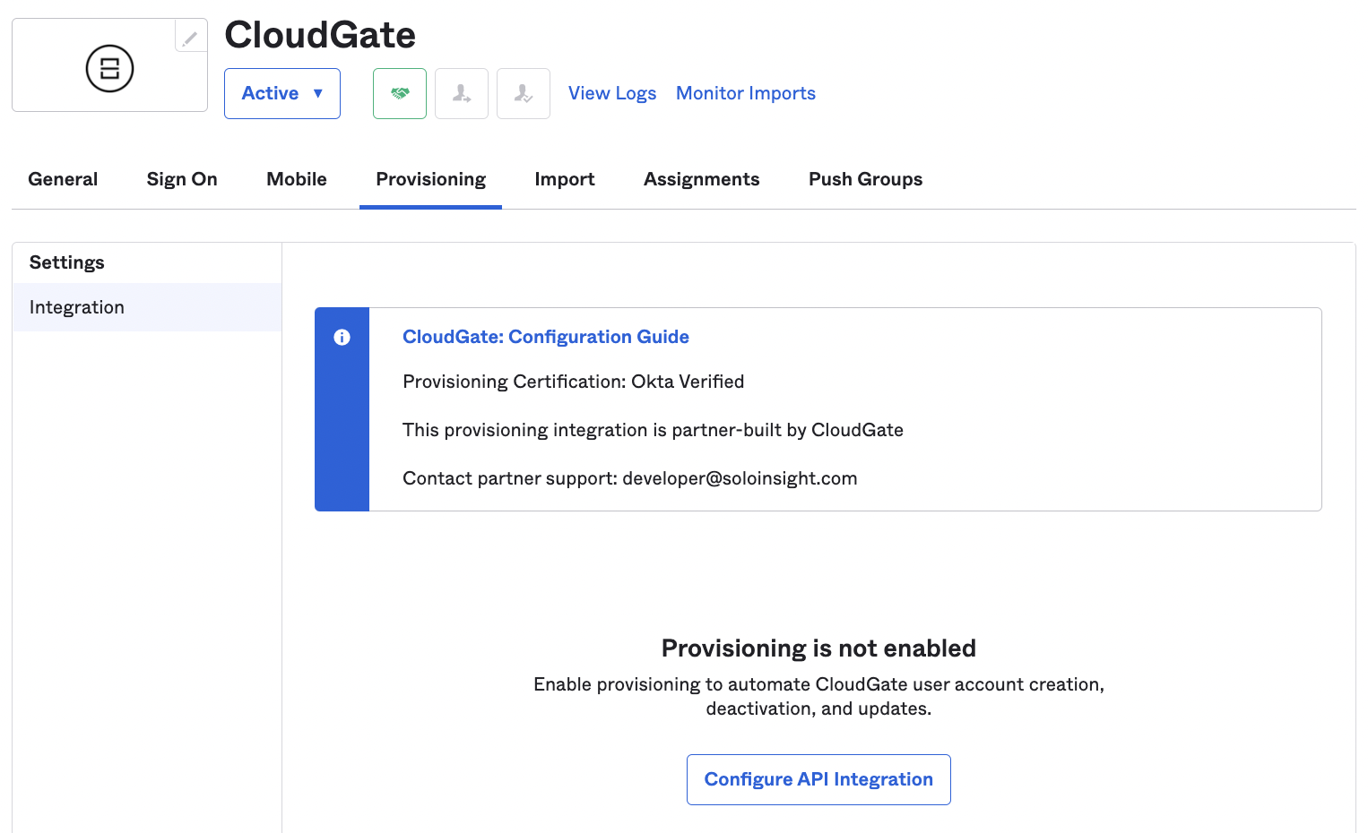

Log into Okta. Go to Admin > Applications and select the CloudGate application. Click on Provisioning.

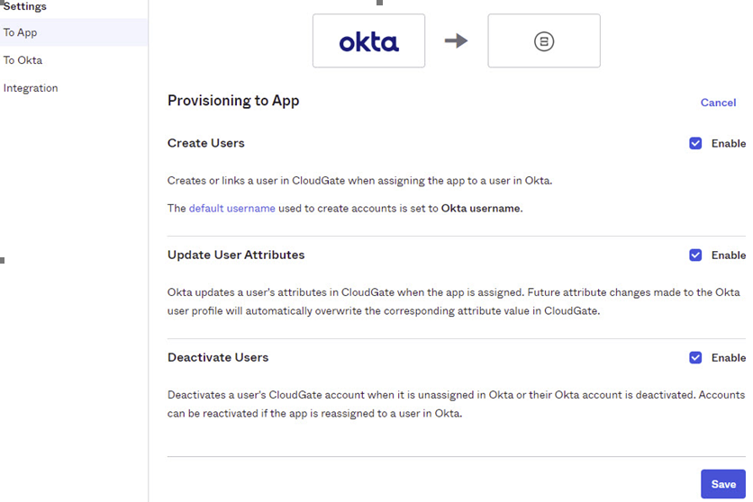
For required fields of SCIM connection admin will be required to log into CloudGate web portal.

CloudGate SSO Configuration
Admin can access the SCIM Connector Base URL by following steps below.
- Login into CloudGate web portal.

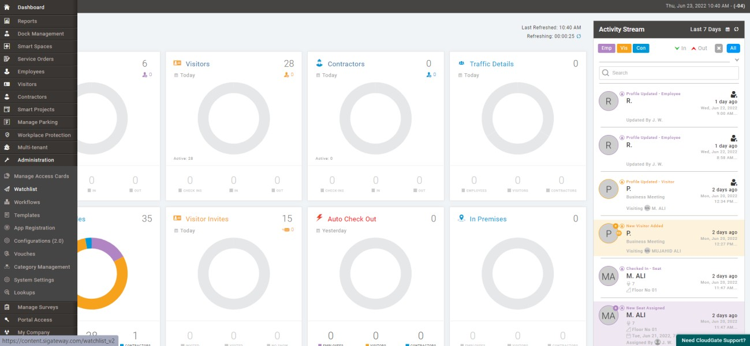
- In the left side menu of the dashboard, Click Administration then click System Settings in its Sub-menu.

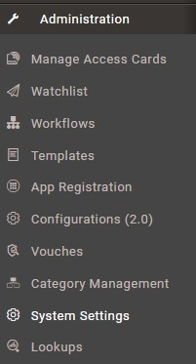

- Go to System Settings > General > Global Settings.
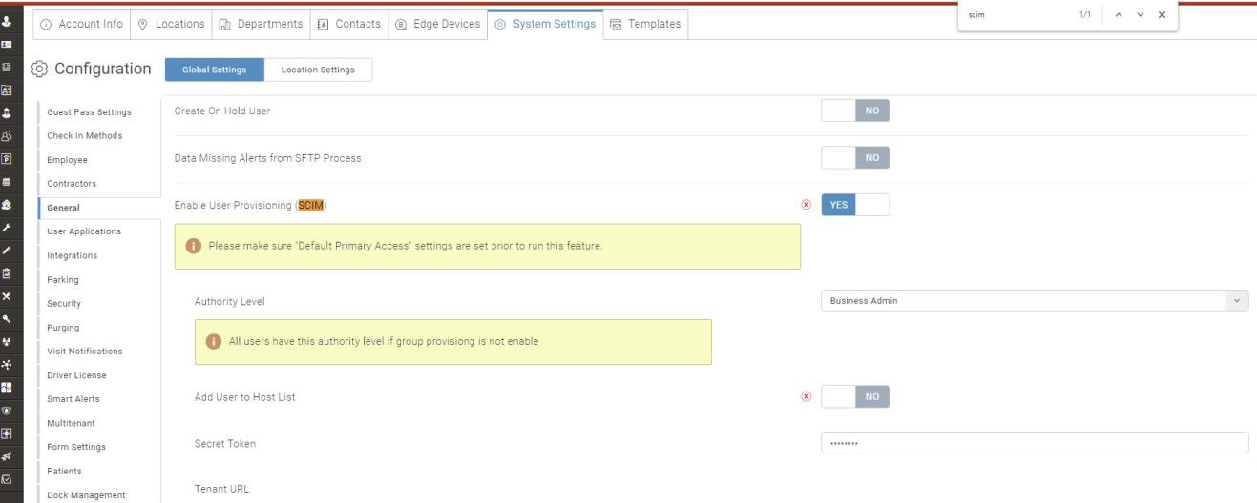
- Here admin will toggle On Enable Users Provisioning.

- Tenants URL corresponds to SCIM connector base URL. Copy the URL from here to paste it into Okta SCIM Connections.
- Secret Token corresponds to the Authorization field that will be visible in Okta when Authentication Mode is set to HTTP Header.
- Attribute Mapping Here user will map attributes as same as its seen below.
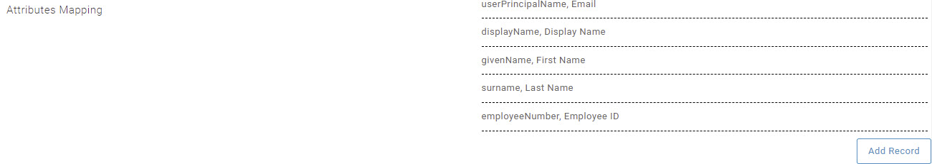
Provisioning to App
- Here admin will click Edit which will open a new window seen below.
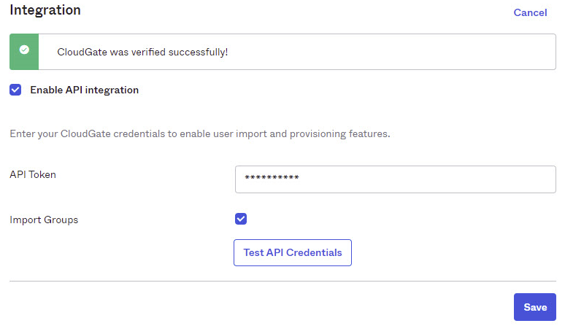
- Here admin will Check Enable API integration.
- Here in API Token admin will add Secret Token copied from CloudGate dashboard settings.
- Here admin will check Import Groups.
- Now to test API credentials admin will click on Test API Credentials.
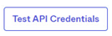
- Admin will see popup once API credentials get successfully verified.
- Click Save.

Mapping Attributes

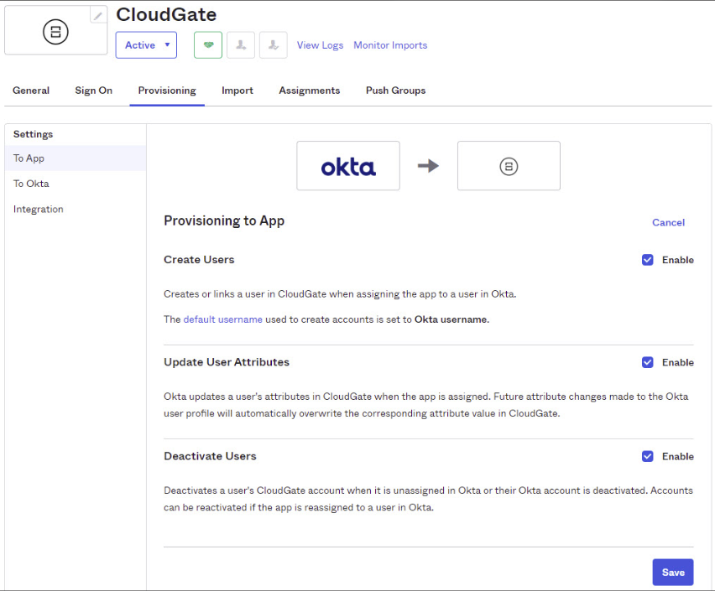

Assigning Application to user
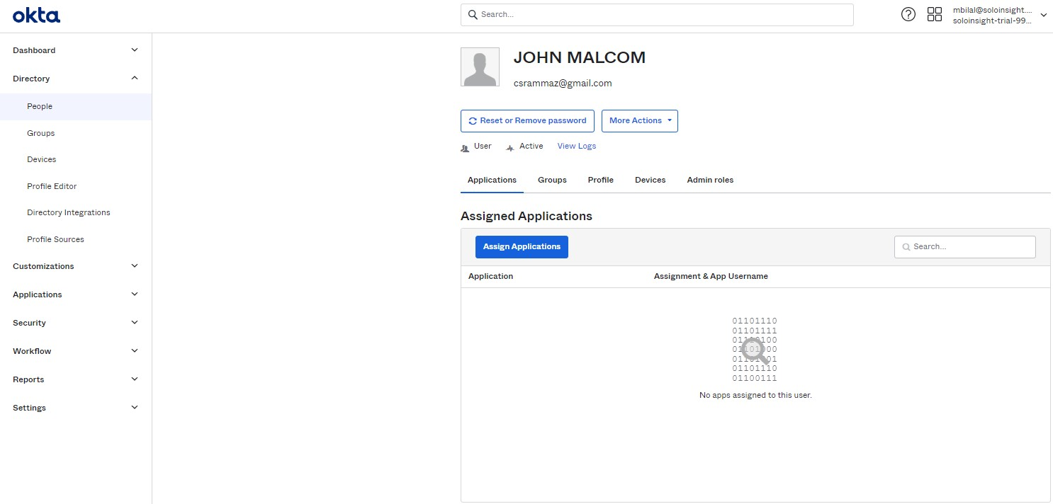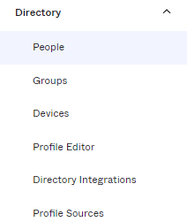

In the left side menu click Directory, then click People from sub-menu which will open a list of user in right side seem below.

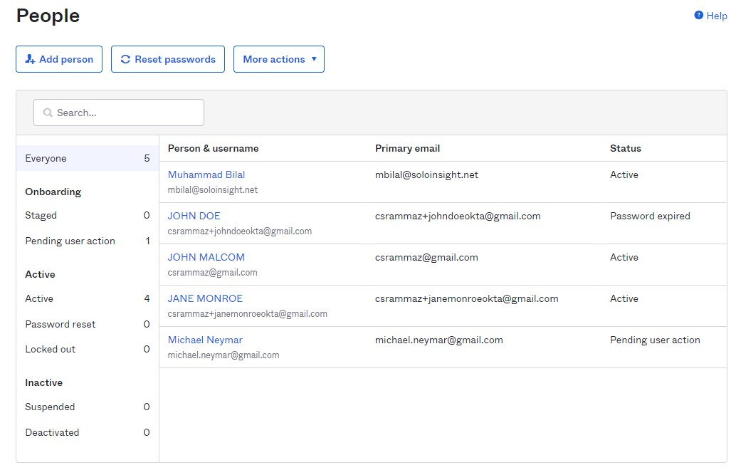
- Here admin will click on required user which will open a new page seen below.

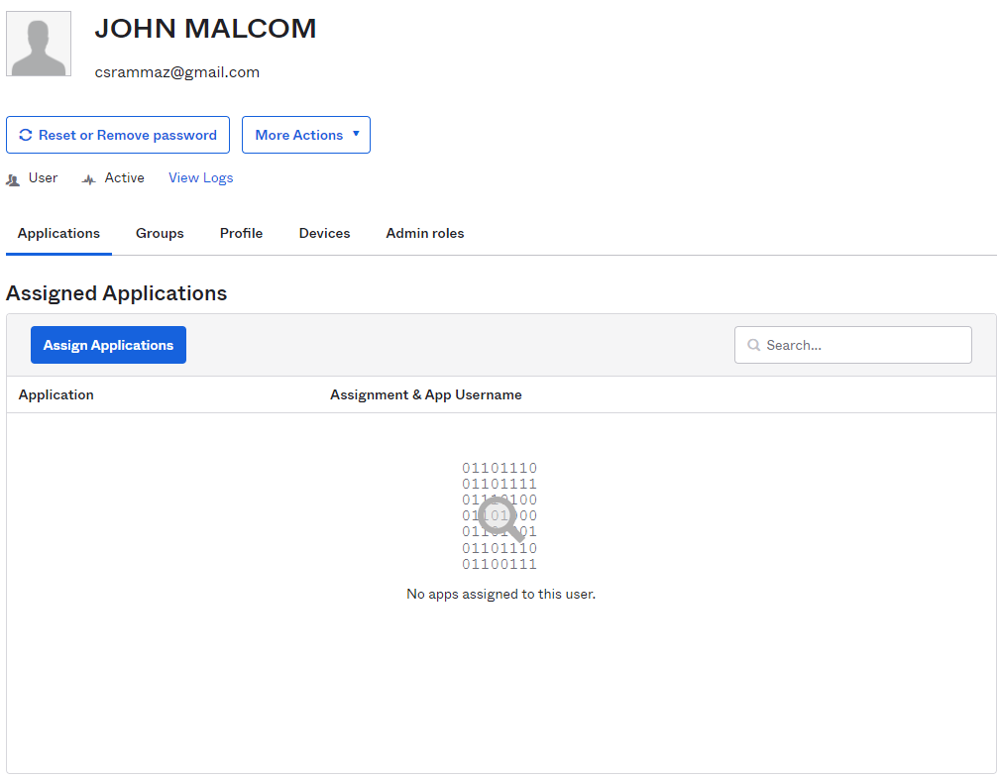

- Click Assign Applications. Which will open a pop-up displaying all available applications for user seen below.

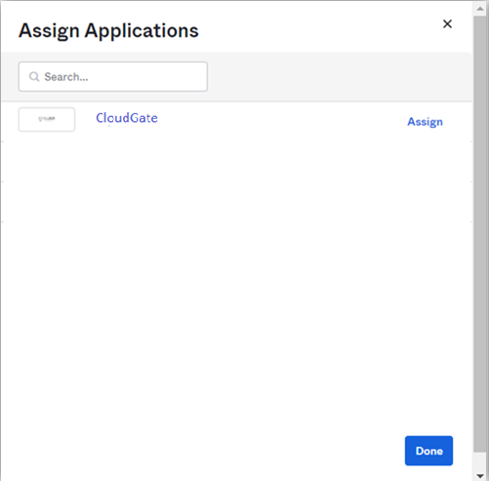

- Here admin will assign required application to user by a single click on Assign Button next to any app in the list. Clicking on assign will open a pop-up where admin will add information for the user seen below.

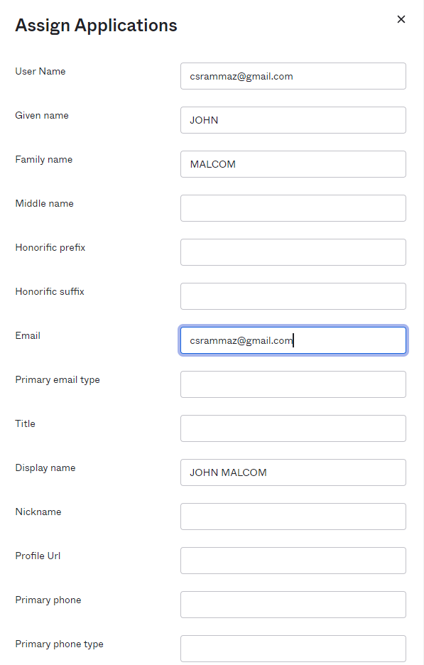

- Once admin has done verifying all required fields, Click Save & Go Back.

- Clicking on Save & Go Back will redirect admin to previous page displaying 1 application assigned to the user as seen below.

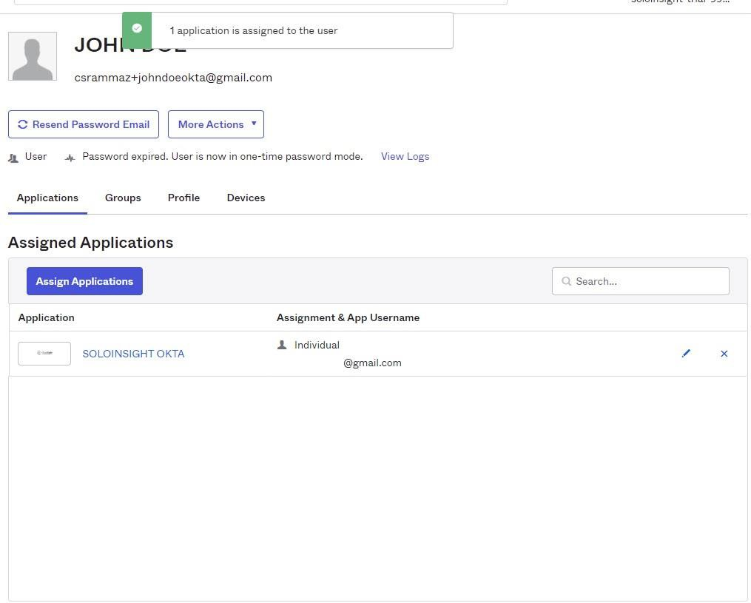

Provisioned user in CloudGate from OKTA
- First login into CloudGate Dashboard.
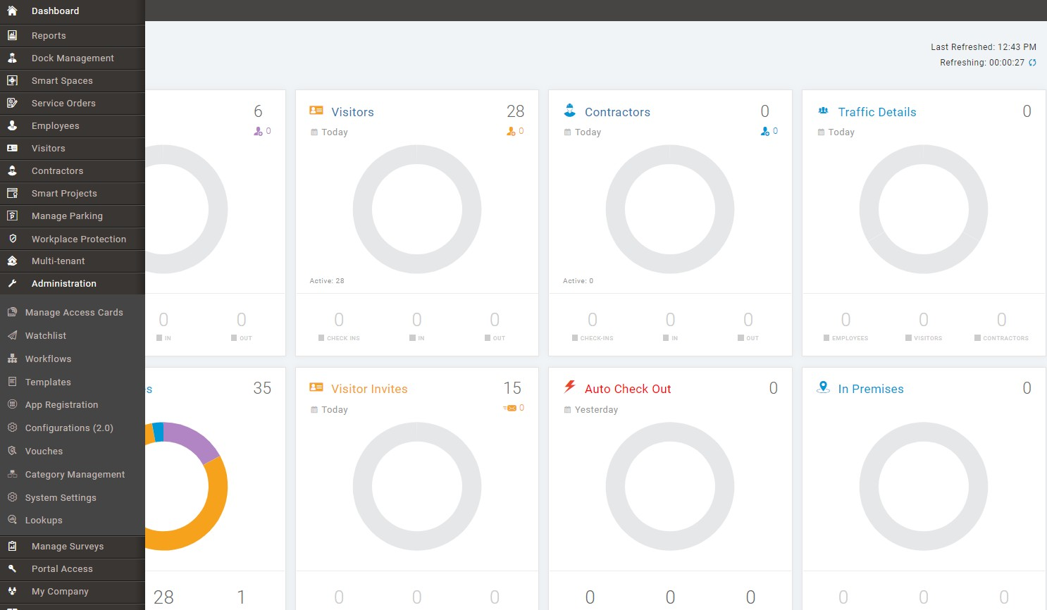

- In left side menu, Click Employees which will open a new page seen below.

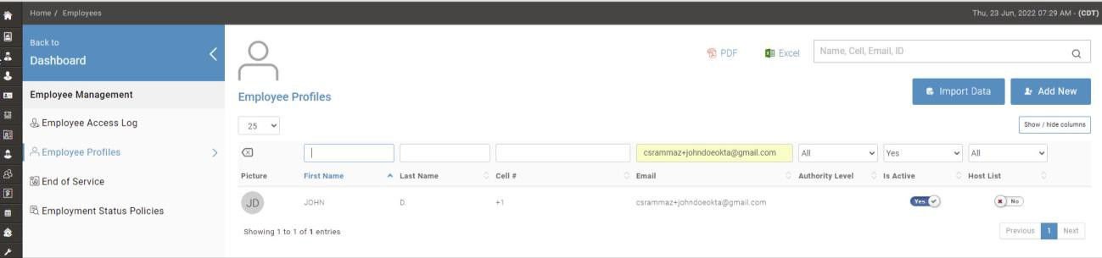

- Here in employees list user can be verified by the same username and registered email.

Known Issues/Troubleshooting

N/A

Note: In current version of application we are not targeting imports so https://okta.cloudgate.ws/scim/v2/sync2/Users?startIndex=1&count=2 is not yet implemented.

